**Name: Nafinur Leo**

**Id: 20-42195-1**

**Course Name: Data Communication**

**Section: D**

**Lab Report Number: 03**

**Semester: 2021-2022 Fall**

**Submission Date: 10-10-2021**

**Lab Performance Task**

ID = AB-CDEFG-H

Here, my id is: 20-42195-1

A = 2, B = 0, C = 4, D = 2, E = 1, F = 9, G = 5, H = 1

x(t) = (H+5)*cos(2π((D+E+5)*10)t) + (H+7)*sin(2π((E+F+10)*10)t)

a)Use ( $2^{H}$ + 2) levels for first method:

Code:

clc

close all

A = 2;

B = 0;

C = 4;

D = 2;

E = 1;

F = 9;

G = 5;

H = 1;

b = 2^H + 2;

f = 50;

fs = 30000;

t = 0:1/fs:0.001;

x =(H+5)*cos(2*pi*((D+E+5)*10)*t+(H+7)*sin(2*pi*((E+F+10)*10)*t));

Nsamples=length(x);

quantised_out=zeros(1,Nsamples);

del=(max(x)-min(x))/(b);

xq=min(x)+(round((x-min(x))/del)).*del;

figure;

plot(t,x,'R' );

hold on;

plot(t,xq,'b','linewidth',1.5);

hold off;

title('Analog Signal Quantization In First Method')

xlabel('Time')

ylabel('amplitude')

legend ('Original Signal','Quantized Signal');

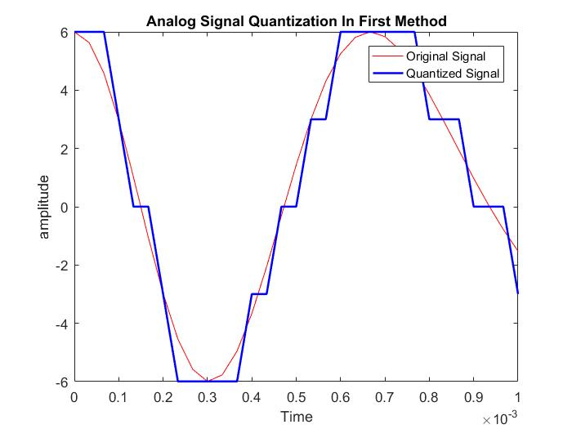

b)Use (12- $2^{H}) levels for second method:$

Code:

clc

close all

A = 2;

B = 0;

C = 4;

D = 2;

E = 1;

F = 9;

G = 5;

H = 1;

fs = 40e3;

t = 0:1/fs:0.001;

x =(H+5)*cos(2*pi*((D+E+5)*10)*t+(H+7)*sin(2*pi*((E+F+10)*10)*t));

L =(12 - 2^H);

delta=(max(x)-min(x))/(L-1);

xq = min(x)+(round((x-min(x))/delta)).*delta;

plot(t,x,'R');

hold on;

plot(t,xq,'b','linewidth',1.5);

xlabel('time')

ylabel('amplitude')

title('Analog Signal Quantization In Second Method')

legend('Original signal','Quantized signal')

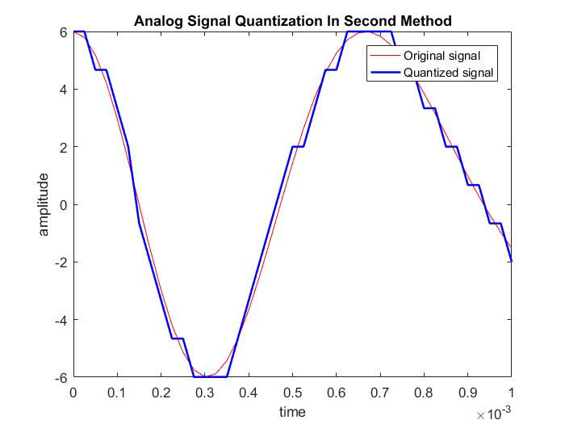

Discussion:

There is some of the bugs concluded with the definite organizational complementation with the functions of the MATLAB. The regression of the functions originated from the libraries inclines the comprehensive objective of this complementation. I face some problems while creating the plot and also face problems while calculation using my student id number. MATLAB takes some time while I try to run because my laptop configuration is low.